**Course Software Setup**

**Exercise 1: Microsoft OneDrive**

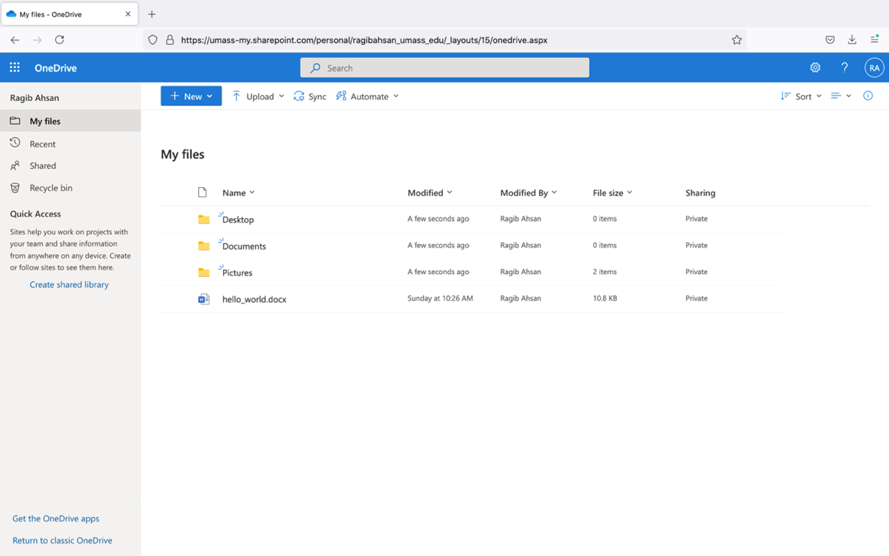

**Exercise 2: Azure Virtual Desktop (AVD)**

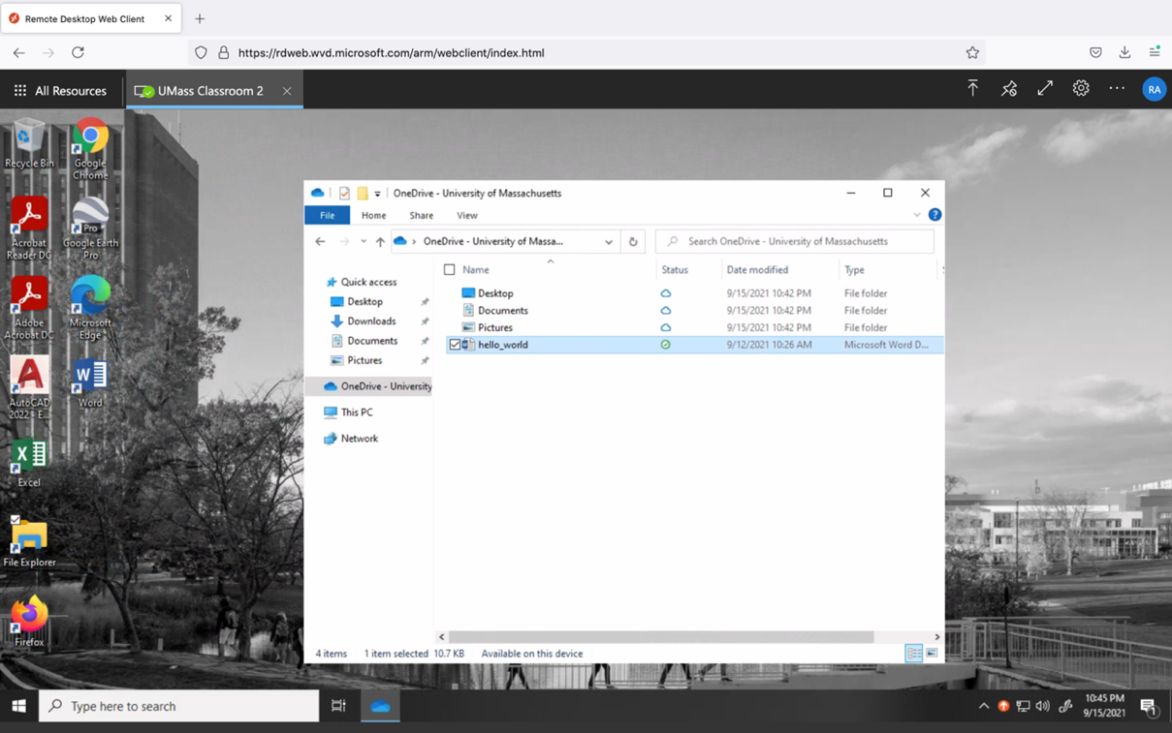

**Exercise 3: RStudio - Hello World**

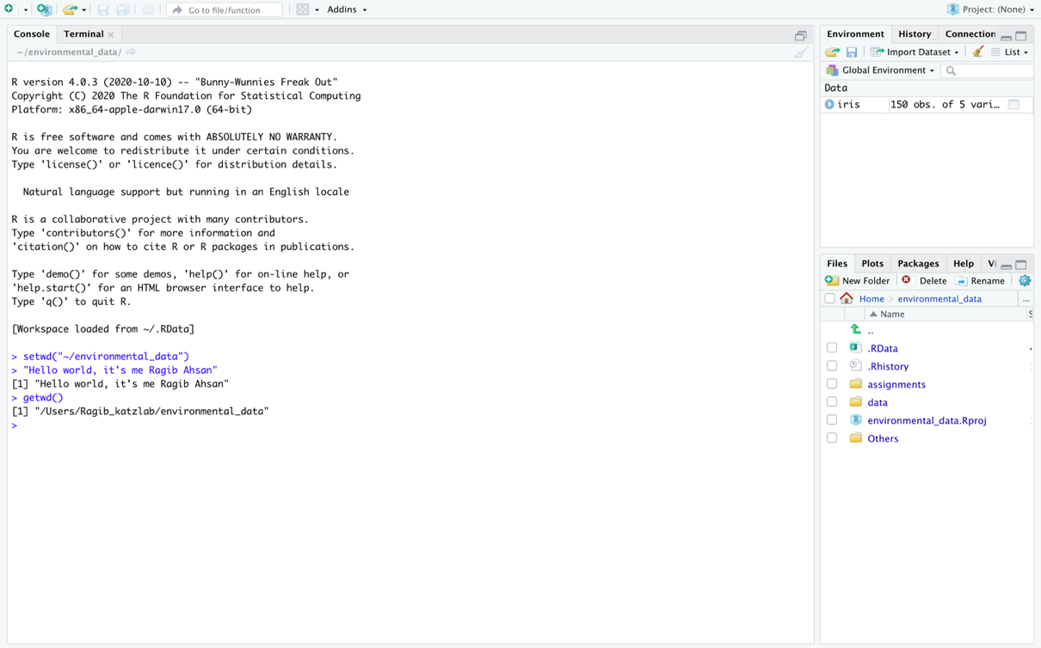

**Exercise 4: Course Folder**

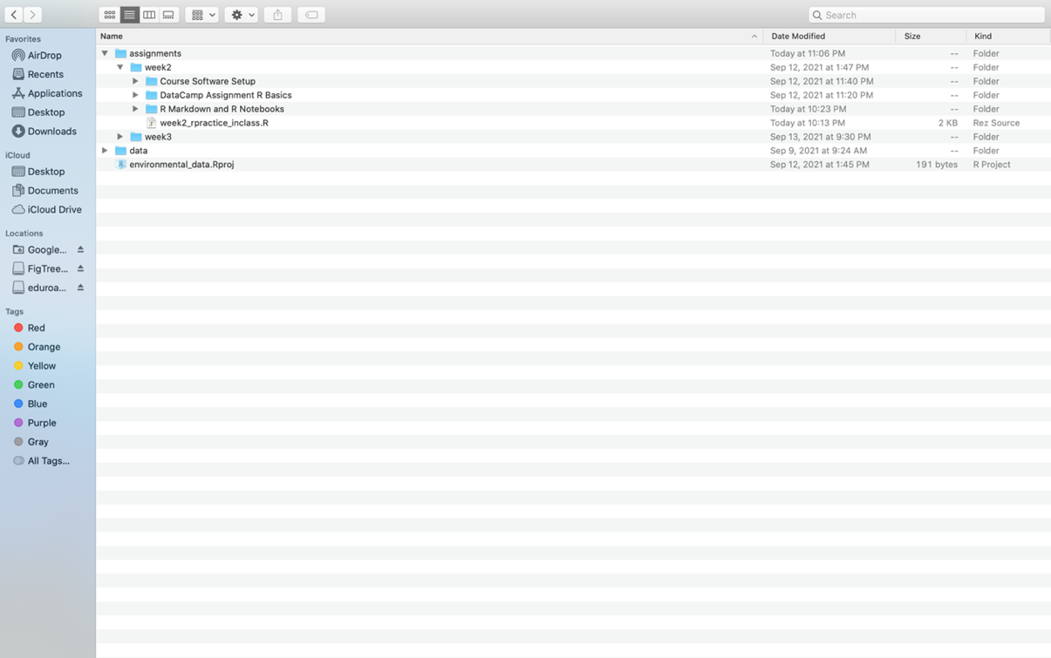

**Exercise 5: RProject with correct project options**

